FABI

... the Flexible Assistive Button Interface

“Do-It-Yourself” - Building Guide

and User Manual

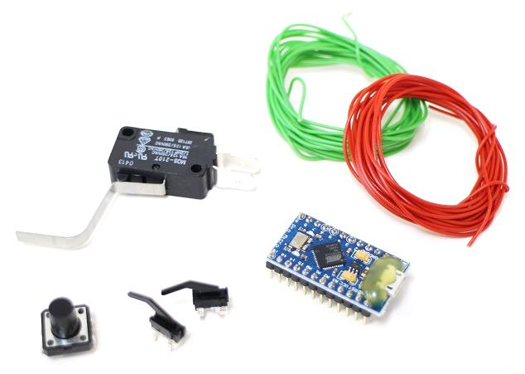

# Welcome to FABI

The FABI (Flexible Assistive Button Interface) allows control of a computer’s mouse cursor and typing desired keyboard keys. This is fun – and it could also be helpful for people who cannot use standard computer input devices – helping them to play games, surf the internet, write emails…

The FABI Interface can be actuated via a dedicated buttons, momentary switches or self-made electrical contacts. FABI consists of a hardware module (a low-cost microcontroller which behaves as a computer mouse and/or keyboard) and a graphical software application to configure the desired functions.

This user manual includes a “do-it-yourself” building guide for your personal FABI device, describing the necessary hardware components and the Graphical User Interface for the configuration of the different functions via the provided software. A configured FABI module can be used on any computer (Windows, Linux or Mac) without installation of special software, because the FABI module behaves exactly like a standard mouse and keyboard which is plugged into your computer. Nevertheless, for configuring the desired functions via the GUI application a driver installation is necessary which is also explained in the software section of this manual.

FABI is an open source Assistive Technology module developed by the AsTeRICS Academy Project of the University of Applied Sciences, Technikum Wien

(see <http://www.asterics-academy.net>).

All software and hardware plans are open source and we took care to use the most affordable components available on the market to establish these functionalities – making FABI the most reasonably priced flexible assistive button interface we know !!

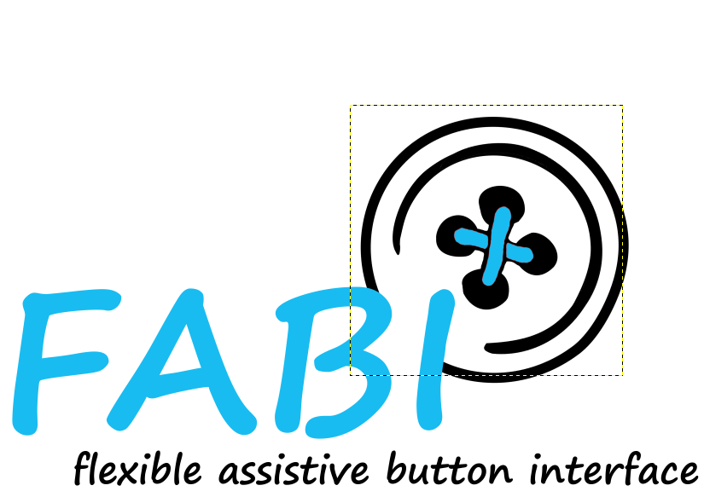.

# Contents

Welcome to FABI 2

Contents 3

Building the Hardware 5

Make your own Switches 9

Soldered connections to the microcontroller 12

Building you own FABI Box 14

Using the Software 18

Placing the firmware into the microcontroller 18

Using the FABI GUI application 21

Selection of function for Button/Switch actions 25

List of needed Material 28

Download Links and Contact 29

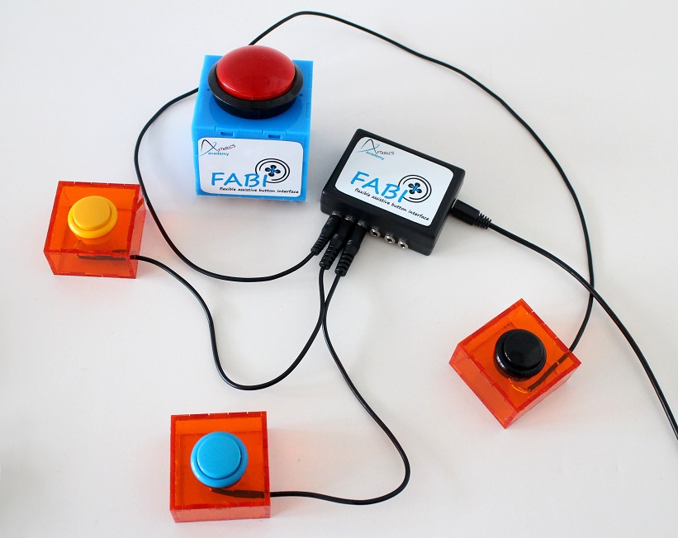

# Building the Hardware

Building your own FABI interface for computer control is easy ! Here, we will show what you need and how to assemble the parts, and we will give some ideas how to build your own alternative input variants using creative low tech solutions.

A working FABI device consists of a microcontroller with USB cable and some additional electrical connections (wires, switches, buttons) – which can be mounted in a way so that they are easily accessible for the user(s).

#### The Microcontroller

The microcontroller is the “brain” of the FABI interface. It monitors which button a user presses and creates the desired/associated mouse- or keyboard activities! The microcontroller is a programmable electronic circuit (actually a small computer on a chip) which can execute the programmed software and performs measurement- and control tasks. Theoretically, various microcontrollers could be used to build a FABI interface – as long as they support the USB HID protocol which makes them compatible to computer mouse- or keyboard devices. In our project, we decided to use an Arduino Pro Micro controller for circa US-$ 4,50 ! This microcontroller has a USB-Port where it can be connected to any computer (Windows, Mac, Linux).

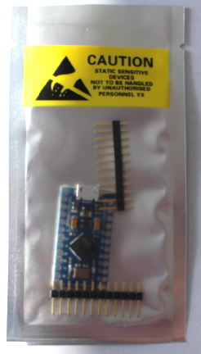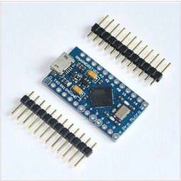

Figure 1: example of Arduino Pro Micro clone which can be used (4,50 $),

We created the necessary software which is now available as open source and can be stored into the microcontroller using the free Arduino Integrated Development Environment. The process of programming the microcontroller is described later in the software section of this manual.

#### Breadboards for Prototyping

The easiest way to connect electrical components (as for example wires and switches) to the microcontroller is a breadboard. A breadboard has mounting holes for components or wires, as well as internal electrical connectors called “bars” and “rails”: The bars are connected vertically (expect for the bridge in the middle) and the rails are connected horizontally, see figure below (right). The black mini breadboard shown on the photo below (left) features only bars, no rails.

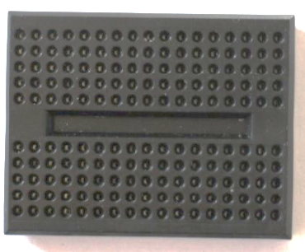 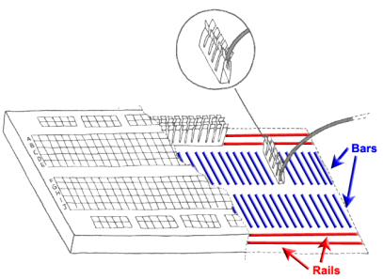

Figure 2: a minimal Breadboard (left), internal connections of a breadboard (right)

Breadboard prototypes are especially useful if you don’t want to use your construction for long or you want to experiment a lot, because the connections are very flexible and easily changeable. For long-term usage, a soldered construction should be used because it’s more robust – especially when you found a reasonable assistive configuration which helps other persons !

When you buy a “naked” Arduino Pro Micro microcontroller from a shop or online store, you probably must solder so-called “pin headers” to the pin holes before you can insert the microcontroller into the breadboard. Afterwards you can connect wires to the desired pins via the breadboard. A controller with pin header connectors attached looks similar to this:

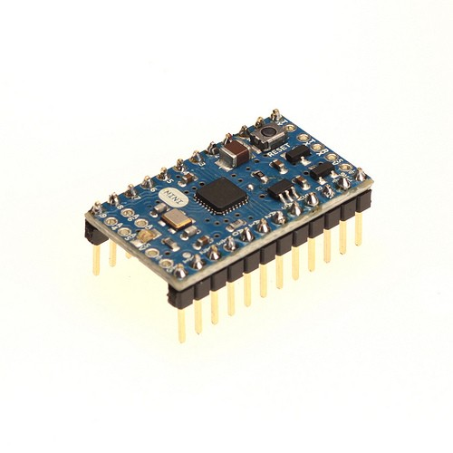

Figure 3: A microcontroller (here: Arduino mini) with pin header connectors attached

#### The Basics of Soldering

The usage of a soldering iron for connecting electric/electronic components is easy - if you pay attention to a few things:

**Safety Rules:**

* **Never touch the tip of the soldering iron**- it gets over 200^C!
* **If you use solder with lead, pay attention that it is not touching your skin and that you do not inhale it**- Lead is poisonous
* **Put the soldering Iron always back into its stand**
* **Always pay attention to what you are doing**!

1. Hold the soldering iron in your dominant hand (like you would hold a pencil). In your other hand you hold the solder
2. Touch the cleaned tip the lead solder and the part where you want to connect something
3. Add about 1mm to 3mm of solder under the tip
4. Add the other part you want to connect with the part one

|  |  |  |
| --- | --- | --- |
|  |  |  |

Figure 4: Basic steps of soldering

#### Soldering the pin header to the controller:

Cut 2 male pin headers to the correct length for the microcontroller (if not already provided), put the small ends through the connector holes of the controller and fix the three parts in a stable position for soldering. Maybe the best idea is to put everything already into the breadboard which gives a good stability. (don’t touch the pin header connections while solder – yes – they get hot ;-)

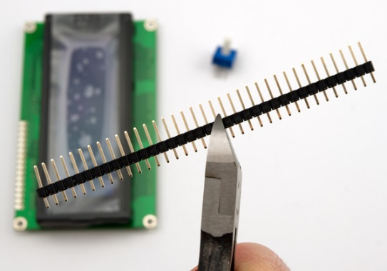 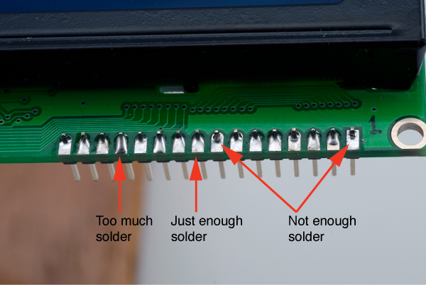

Figure 5: Cutting the male pin header, applying right amount of solder

#### Attaching wires to the microcontroller in the breadboard:

For connecting a switch to the microcontroller we need to attach one wire to the ground potential (zero volts, labelled “GND” at the microcontroller). Then we attach another wire to another “Pin” – you can choose one from 2-7 as these are supported in the software. At this pin connections, the microcontroller then receives the ground potential when the switch will be pressed.

**Remove the isolation from the wires on both ends, so that you can insert the bare metal wire into the breadboard. Make sure that at least 5mm bare wire goes into the breadboard connection.**

The finalized microcontroller with soldered pins and two attached wires should now look similar to this:

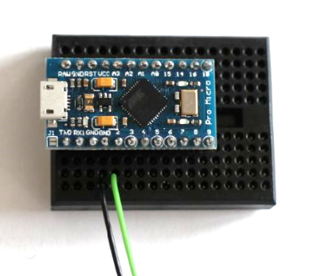

Figure 6: How to connect wires with microcontroller,   
here using a breadboard: black wire for GND pin, green wire for input / signal pin 2

The FABI software is programmed so that we can use any pin from 2 to 7 to attach the ground potential. The microcontroller will then react by performing one out of 6 functions which can be defined in the configuration software**.**

#### Two wires: one switch !

The two bare wire ends which now stand off can act as a simple switch: By connecting them you trigger the signal to the microcontroller so that the desired actions can be performed. This represents the most basic switch possible …

## Make your own Switches

Switches are a simple method for computer control – if supported well in the computer software and/or operating system. Accessible switches are supported by various kinds of assistive software applications like On-Screen-Keyboards or Alternative Augmented Communication grids. A standard accessible switch (without the computer control box) can cost 100 $ or more if you buy it from a professional reseller – this is 10 times the cost of our whole FABI device ….

Switches attached to FABI can create many different computer input actions like all kinds of mouse clicks, mouse movement and more (see the software section for details). The only things you need to add to your microcontroller are suitable wire connections and switch contacts for the user. In the following, a few simple ways to create different switch contacts will be presented:

#### The most simple switch: Connect two wires !

The simplest switch is built of two wires which are connected to pin and to the ground pin (GND) of the microcontroller. If the two wires do not touch each other, there is connection between the two pins and no signal is received. If the two wires touch each other, the resistance is decreased and the microcontroller receives the ground signal – so it can detect that the button was pressed.

|  |  |
| --- | --- |
| No Signal | Signal |
|  |  |

Figure 7: Simple switch made out of two wires, left picture: switch is inactive; right picture: switch is activated

#### Cardboard / foil - Switch

The cardboard / foil switch works the same way as the simple wire connection described above, but it is more user friendly because you can use the cardboard as a haptic momentary contact switch and press it witch different limbs / fingers / even toes ! – And: it costs next to nothing !

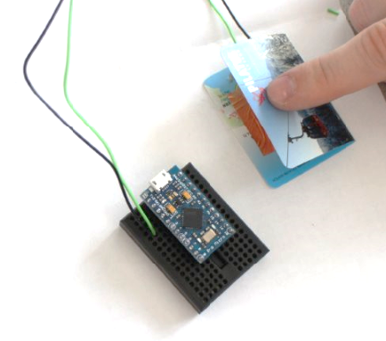

Figure 8: Cardboard / foil switch

Here we used copper foil (or aluminum foil) and a piece of thick paper (e.g. a business card of someone you will never contact ;-) to build the accessible switch:

|  |  |  |
| --- | --- | --- |
|  |  |  |

Figure 9: material for low tech switch: left picture: piece of carton, middle picture: copper foil, right picture: switch wire

Fold the carton in the middle like in figure 8. Afterwards stick the two pieces of foil, one of each side of the inner areas of the cartoon including a wire between cartoon and foil on each side (see figure 10).

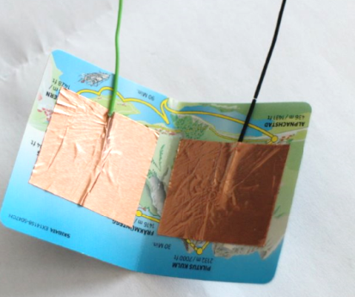

Figure 10: copper foil and the two wires stick on the inner side of the cartoon

Now connect the wire to the microcontroller like in figure 8. By pressing the upper side of the cartoon to the underside of the cartoon together that the two foil pieces can connect, the switch is activated. For mounting the cardboard / foil switch in a convenient position, velcro-tape or double-sided sticky tape could be reasonable methods …

#### Re-Using an existing Switch

There are various possibilities for finding switches in old electrical or household devices. In fact, all you need are two metal contacts ! – You can use an old light switch or an on/off switch of an old radio – the options are endless. Here we show a microswitch which can be found e.g. in several computer joysticks. Of course you can also buy one from the store ;-)

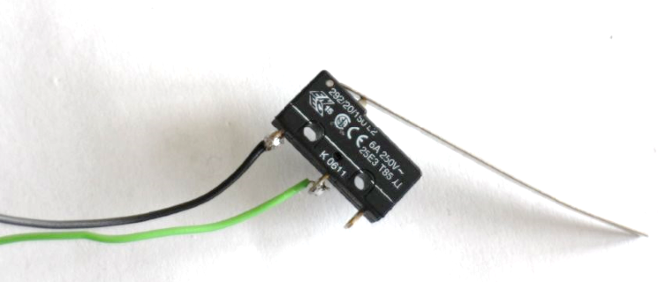

Figure 11: (Re-)using an existing switch

To solder the wires to the switch, the best is to fixate the switch in a vice. Then connect the wires to the switch using solder, as shown in figure 12.

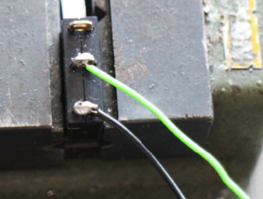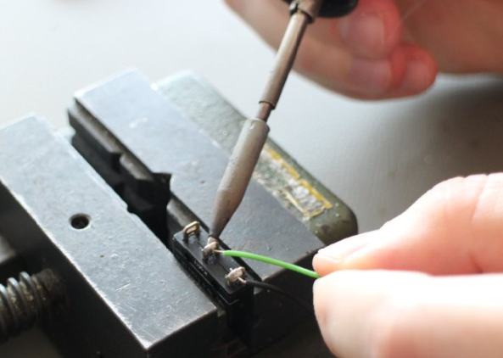

Figure 12: how to solder the wires to the switch

## Soldered connections to the microcontroller

If you want to use your device for a longer period or you found a helpful configuration for another person, your solution should be very robust and stable. It will be a good idea to remove the breadboard and solder the wire connection directly to the microcontroller.

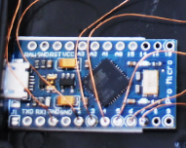

Figure 13: example, where wires are directly soldered to the single pins of the microcontroller

For soldering, follow the basic soldering introduction above. Pay attention that you do not burn the device by applying too much heat to the pins (5 seconds at about 350 degC should be fine). The figure above shows a new microcontroller (without pre-soldered male pin headers). Here, enameled copper wire was used for the connections – you can also attach other wires of course but pay attention not to create short circuit connection to other pins via loose wire parts…

If you already attached the male pin headers, they will be difficult to remove. In this case it might be better to buy female pin header connectors where you can attach the microcontroller’s male pin headers. Thereby you create a stable but still removable connection and you can solder your wires to the female pin header connections.

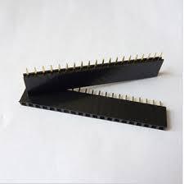 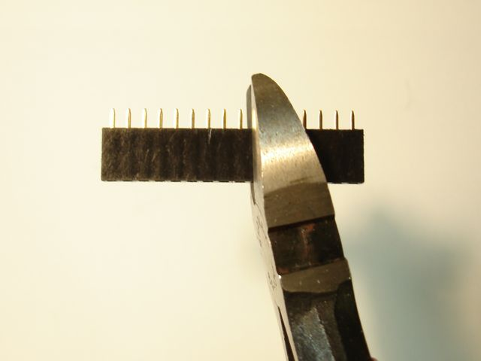

#### Connect switches via jack plugs and stereo cable

It might be reasonable to solder the wires from the microcontroller to a 3,5mm stereo (or mono) jack plug. With this solution you have the possibility to connect a variety of input methods to the jack plug via a stereo audio cable. You could also connect standard accessible switches which (most probably) come with a 3,5mm mono jack plug.

Solder one wire to a GND-pin of the microcontroller and another wire to the desired input pin (labelled 2 – 7 in case of the Arduino Pro Micro). The other end is soldered to the 3,5mm jack plug as shown in figure 14: The long end of the jack plug should be connected to the ground wire on of the shorter end to the pin-wire. Now you can easily connect any device with a stereo cable to your jack plug.

|  |  |
| --- | --- |
| Receive Pin  GND |  |

Figure 14: left picture: jack plug, right picture: stereo cable

|  |  |
| --- | --- |
|  |  |

Figure 15: how to solder two wires to a stereo plug

Unscrew the tip of the jack plug. Then connect the ground wire and pin wire as shown in the left pictures above using the soldering iron. After successfully finishing the soldering step, you can screw the housing of the stereo cable as shown in the right picture above.

## Building you own FABI Box

|  |  |
| --- | --- |
|  | Figure 16: FABI box |

If you would like to protect your microcontroller in a nice case and add flexible connectors, it might be an idea to build a FABI box with 6 jack plugs, to connect 6 different switches to the microcontroller pins 2, 3,4,5,6 and 7. These 6 switches can then be configured with the FABI GUI software for different alternative computer control functions as explained in next chapter “software”.

|  |  |
| --- | --- |
|  | The first step to build a FABI box is to mark the drill holes for the 6 jack plugs (long side of the box) and the USB connection (short side of the box).  It is important that the single jack plugs are far enough away from each other that they do not disturb each other. The distance between two plug holes should be at least 10mm. Pay attention that the holes are in the middle of the box! |
|  | Fix the box with the vice |
|  | With a pointed punch and a hammer the holes which should be drilled are marked for an easier handling with the big drill |
|  | After the preparation explained above, make the holes (6mm) for the jack plug and the USB cable carefully with the drill  But before using the drill, please read the user manual carefully!  Pay attention to your body especially the fingers! Always use the vice while working with the drill |
|  | Now the box should have 6 holes for the jack plug and one hole for the USB cable |
|  | Remove all disturbing plastic elevations inside the box |
|  | Strip the isolation of a switch cable piece (with the length of the box) |
|  | Then you can start to screw the jack plugs in their single holes and connect them with the strip isolated switch cable (ground connection) at the longer end.  (put the switch cable through the small holes in the longer end of the jack plug) |
|  | Solder the switch cable and the long ends of the jack plugs together  (for a good electric connection and to be sure that it do not fall apart) |
|  | Now it is time to connect the single pins to the jack plugs  For this a wire out of copper is used which is very flexible and cannot brake easily.  For a better electric connection it helps to burn the end of the wire which is connected to the jack plug or to the microcontroller with the lighter that the isolating layer is 100% removed |
|  | Cut pieces of short copper wire and connect the single pieces to a pin (2-7):  First fill the pin hole on the microcontroller up with solder then heat the solder in the pin hole again and add the copper wire.  Attention it takes about one second till the solder is tight again; therefore you have to work fast and precise!  Then connect the copper wire from each pin to a jack plug (smaller end)  One copper wire is used to connect the switch wire which connects the ground connection of each jack plug with a GND pin of the microcontroller |
|  | In the end your result should look like the picture on the left side every pin is connected to one jack plug end and the ground connection is also connected to the microcontroller  Now you can screw the cover to the box and download the software |

Figure 17: User manual, how to build a FABI box

# Using the Software

The FABI hardware needs the proper software which provides all its functionalities. The FABI software is distributed as part of the AsTeRICS open source framework (<http://www.asterics.org>) and separately at the homepage of the AsTeRICS Academy project (<http://www.asterics-academy.net>). It consists of the following two parts:

* **The software which runs in the microcontroller (the so-called “firmware”):   
  It creates the desired mouse and keyboard inputs for the attached computer**
* **The FABI GUI software application which runs on a Windows PC. It communicates with the software on the microcontroller and can be used for the configuration of the desired functions of the attached switches**

This chapter will describe the necessary steps to program the firmware into the microcontroller and then shows the features of the FABI GUI to setup your desired behavior of the FABI device !

For performing these steps you need to download the FABI software packages from the above sources. If you have any problems or questions regarding the software download or installation, just write us an email to [office@asterics-academy.net](mailto:office@asterics-academy.net)

## Placing the firmware into the microcontroller

For placing the firmware into the memory of the microcontroller (a prcess which is also called “flashing the firmware”), we will use the Arduino Integrated Development Environment. This has the advantage that you could also view and/or change the source code of the program if you are interested. The Arduino IDE can be downloaded from <http://www.arduino.cc>.

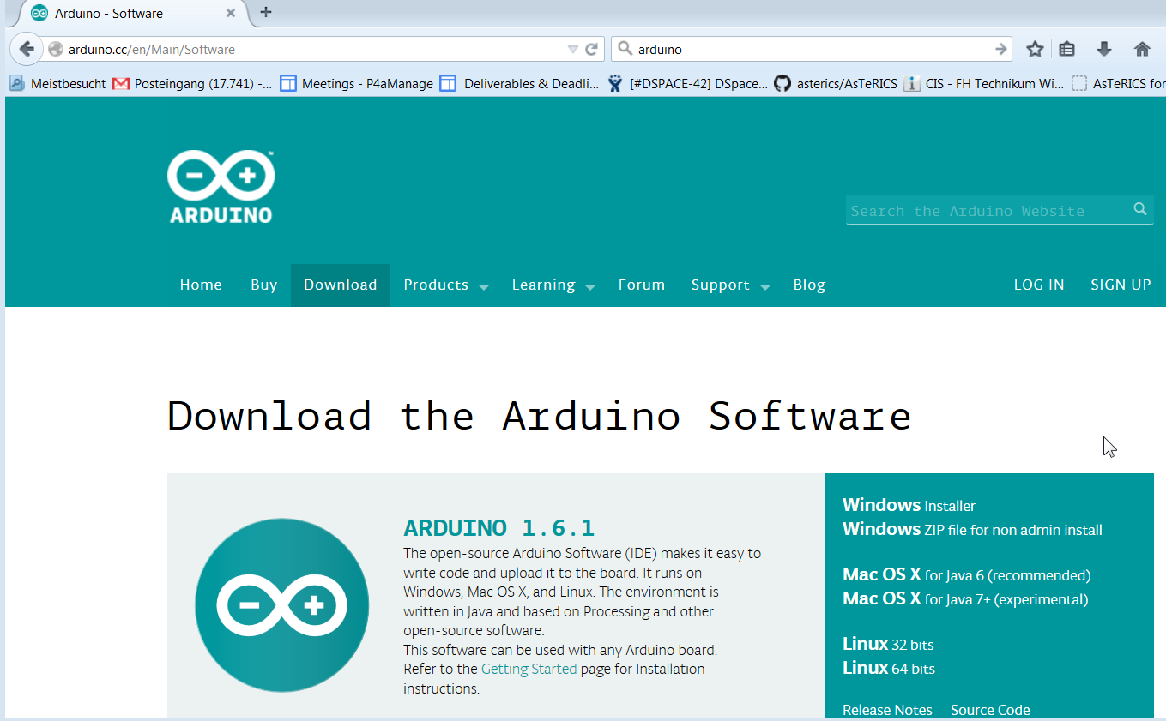

After installing the Arduino IDE, attach the microcontroller (Arduino Pro Micro) via an USB micro cable to a COM Port of your computer (the following screenshots show a Windows PC but the procedure is similar for Linux and MAC)

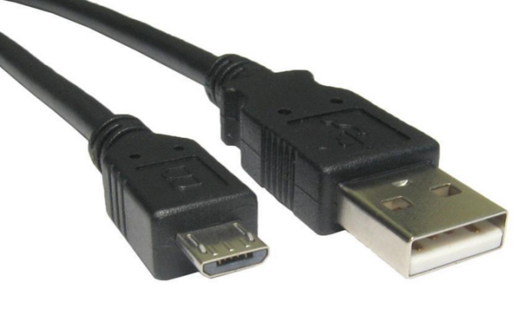

Connect this end to a USB port in your computer

Connect this end to the microcontroller

Figure 18: Micro USB cable

After making sure that the device is securely connected to the computer, the driver for the so-called “COM-Port” – for communication with the microcontroller – must be installed. Please follow the instructions here: <http://arduino.cc/en/Guide/ArduinoLeonardoMicro>

To check if the COM port has been installed, go to Control Panel on your computer, and select Device Manager.

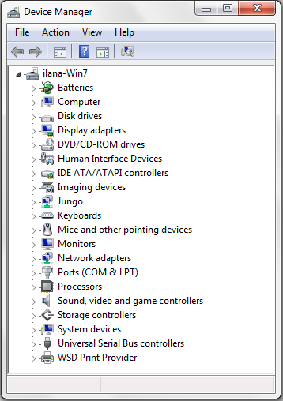

The COM port for your microcontroller should appear here. You can click on “Ports” to extend the list of ports connected to your computer. An entry like “Arduino Micro (COM7)” should appear. The number is arbitrary and gets automatically selected by your computer. Note the COM-Port number !

Figure 19: How to find the right com port

Now start the Arduino IDE and open the FABWare.ino file from the AsTeRICS download package. Select your **COM-port** number in the menu: **Tools-> Serial port**:.

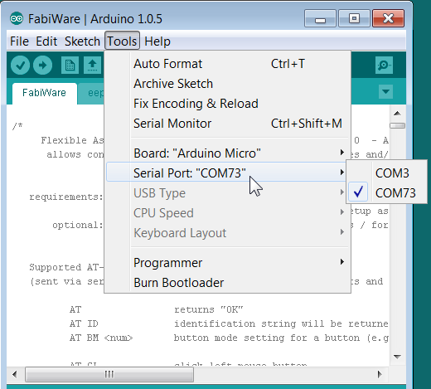

Then, select “**Arduino Micro**” in the menu **Tools->Board**:

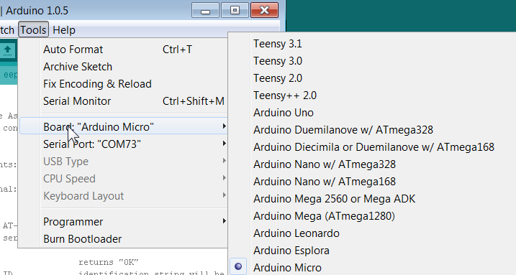

You should now be ready to translate the FABIWare source code into an executable firmware which will then be stored into the microcontroller. Perform all these steps by simply pressing the “Play”-Button in the Arduino IDE. If – after several seconds – the message “done uploading” appears, the process was successful and you can close the Arduino IDE.   
(else: contact: [office@asterics-academy.org](mailto:office@asterics-academy.org) …;-)

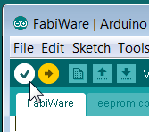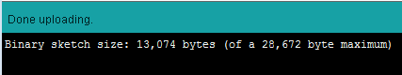

## Using the FABI GUI application

When the FABI firmware has been programmed into the microcontroller, you can use the FABI GUI application (currently only available for Windows) to configure your desired FABI functions. After starting FABIGUI.exe, the following window shall be displayed:

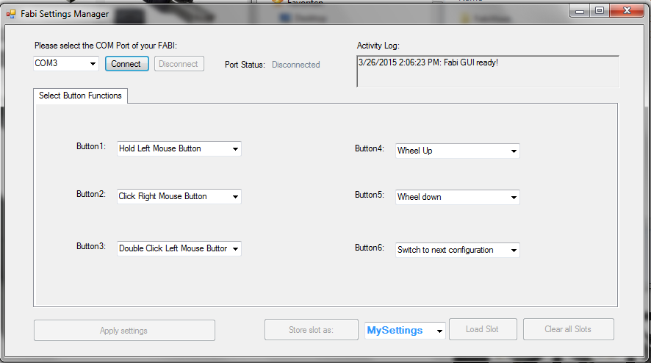

Figure 20: FABI user interface

#### Connecting the FABI Device

In order to be able to use the features of the FABI GUI, the FABI device must be connected to the application. To connect the device, follow the following steps:

1. Make sure your device is securely connected to your computer.
2. Select the appropriate COM port (communication port) in the combo box at the top of the application window. If the combo box appears empty, it means that no port has been detected. In this case, please reconnect the device and wait for the COM ports to be updated, and then click on the drop menu to refresh the COM port list or restart the application.
3. Once the COM port is selected, click the Connect button on the right hand side of the combo box. When the device is connected, a confirmation message will appear in the activity log at the bottom of the application window, like the example below:

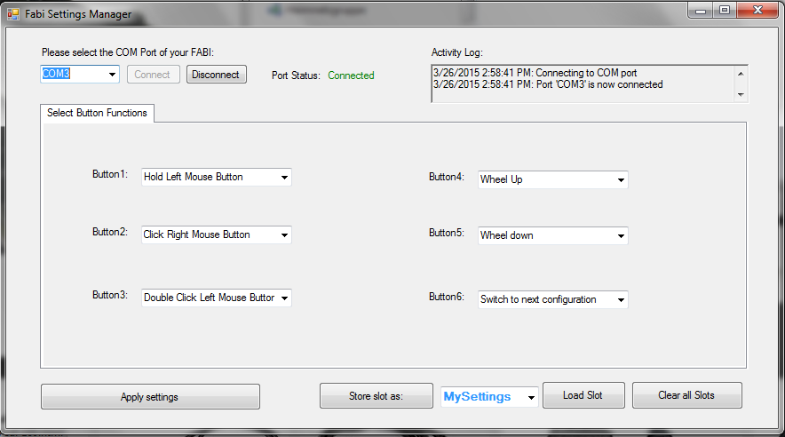

Figure 21: Program connected to the right port of the microcontroller

#### Port Status

The port status is located at the top right hand corner of the application window. It displays whether the device is currently connected or disconnected from the user interface. The functions of the user interface may only be used if the port status is “connected”.

#### Activity Log

The activity log is located at the bottom of the application window. It provides messages in accordance to the use of the application.

#### Applying Settings

The settings selected for the various features will not be automatically changed. After you are done fine tuning the features of the FABI user interface to your liking, you may click “Apply settings”. Once the settings have been applied, you will receive a confirmation message in the activity log, and you will be able to use the FABI user interface with the new configuration.

#### Saving, Loading and Clearing Slots

If you have selected Button Functions settings that you would like to use again, you may save them as a memory slot into the microcontroller, which you can later re-load and use.

When you save a new slot, you can first give it a name that will help you remember the configuration. To write in a new name, click on the click on the drop down menu on the right of the “Store Settings as” button.

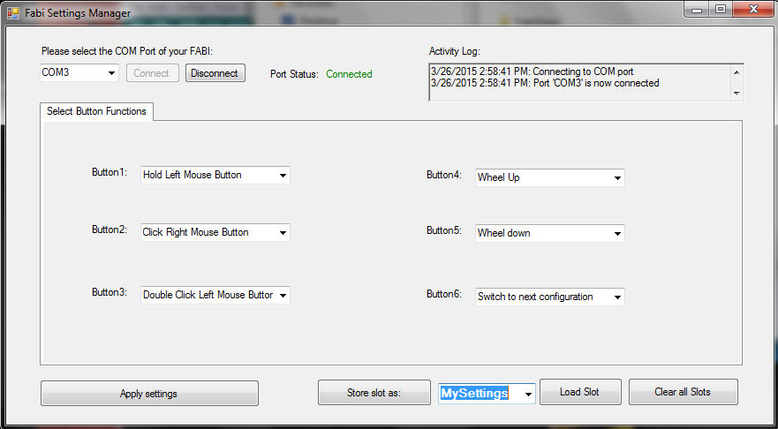

Figure 22: Saving, Loading and Clearing Slots

Clicking will highlight the default text, as seen above. You may now the type the new name, which will replace the default text. After typing in the new name, click the “Store Settings as” button.

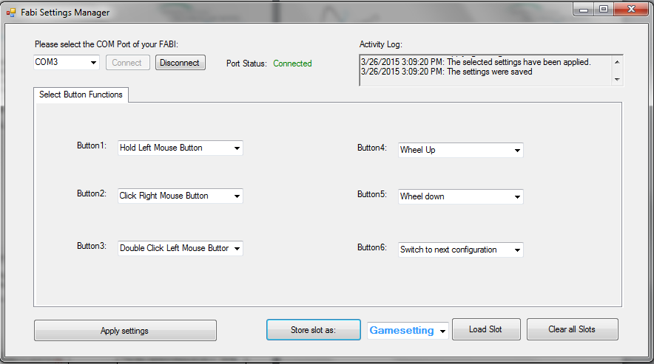

Click this button to save the configuration under the name entered in blue on the right

The new name in this example is “Game settings”, which can save the settings for the required input actions when playing a particular computer game

Figure 23: How to rename and store desired settings of single button functions

When your new configuration is saved, confirmation messages will appear in the activity log:

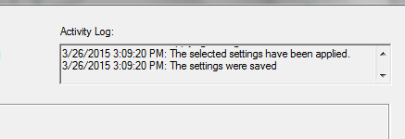

Figure 24: confirmation message, that new configuration is saved

When you store the settings, there is no need to apply them first, because the “store settings” button applies the settings before saving the configuration (as you can see in the activity log shown in the above image). You can save more than one configuration of settings. To save multiple setting configurations, simply change settings for the new configuration and repeat the above steps to save the new setting configuration under a different name.

When you wish to use a particular configuration of the settings which you have saved before, expand the drop down menu by clicking the black arrow and choose the desired configuration. Once you have chosen it, click on “Load Slot”, and the saved settings will appear in the application.

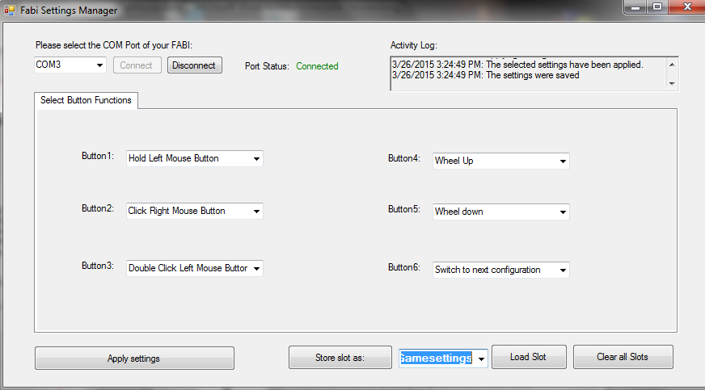

Click “Load Slot” to begin using the saved configuration

Click here to expand the drop down menu and select the slot with the desired configuration

Figure 25: Load and select desired configuration

When a slot is loaded, you will receive the following confirmation messages in the activity log:

If you would like to change the settings of a saved configuration, follow the next steps:

1. Load the slot (as described above) that you want to change.
2. After the slot is loaded, change the settings as you wish.
3. Click “Store settings as” to re-save the changes to the slot. You will receive the same confirmation messages in the activity log as when you save a slot for the first time (see image in previous page).

If you no longer wish to use any of the saved configurations, you may delete all of them at once by clicking “Clear all slots”.

## Selection of function for Button/Switch actions

In the FABI user interface you can associate up to 6 Button/Switch signals to different computer input control functions like“right mouse click”, “wheel up” or “Hold Mouse Button”. In the following chapter, the selection of these alternative actions is explained.

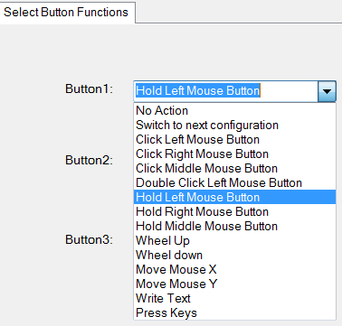

Figure 26: different alternative actions of the FABI GUI

#### 1: No action

If “No action” is selected from the function menu, then no action will be done when the button is pressed (yes: this also could be desired sometimes ;-)

#### 2: Switch to next configuration

This action is only relevant if you saved multiple FABI setting configurations to memory slots . Once you have multiple configurations saved, you can assign the action of switching between the configurations saved on different slots in the application.

#### 3: Click left/middle/right/ middle mouse buttons

With this function you can simulate a left/middle or right mouse click with the selected button

#### 4: Double click left mouse button

Double clicking the left mouse button may be necessary in cases such as opening a file. However, producing a double click with the regular click mouse button function may not be convenient, so you may assign a double click of the left mouse button instead.

#### 5: Hold left/middle/right mouse buttons

The click mouse button options imitate a quick mouse click, however sometimes it is necessary to continue pressing a particular mouse button (for example, when dragging a file, continuously pressing the left mouse click is necessary). For this purpose, the FABI user interfaces application allows assigning a button holding function to one of the stick movement directions.

#### 6: Wheel up/down

The options “Wheel up” or “Wheel down” emulate a scroll wheel, otherwise known as the mouse wheel. The picture below displays an example of a scroll wheel. Triggering the “Wheel up” option results in upwards scrolling, while “wheel down” results in downward scrolling.

#### 7: Mouse move X or Y

The cursor movements on the computer screen occur in both vertical and horizontal direction, where vertical movements are movements across the X axis and horizontal movements are movements across the Y axis. The “Move mouse X” and “Move mouse Y” emulate computer mouse movements and when triggered they result in mouse movements in the selected axis

These two options also require a speed parameter to indicate how quickly the cursor should move in each case. The input field for the speed parameter appears once the mouse move option is selected.

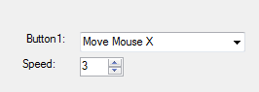

Speed parameters for each of the mouse movement options. Press the upwards or downward arrows to increase or decrease the speed, or press on the number to type in the speed manually

Figure 27: Screenshot of "Move Mouse X" action,   
the same principle is valid for Move Mouse Y

#### 8: Write text

The “Write text” option allows you to type a particular text excerpt each time you perform an action (for example, write “Hello” when you press the button).

When you select “Write text”, a blank text box will appear under the drop down menu as shown below: Click on the text box and type the desired text.

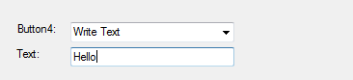

Write text here

Figure 28: Screenshot of "Write Text" action

In this example, “Hello!” will be written each time the button is pressed

#### 9:Press Keys

The “Press Keys” function allows you to perform a selected key command by pressing the button.

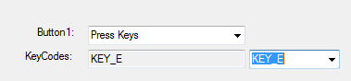

Choose desired key

Figure 29: Screenshot of "Press Key" action

In this example, “E” will be written each time the button is pressed.

## List of needed Material

|  |  |
| --- | --- |
| **Microcontroller** | * Arduino Pro Micro (or clone) - or alternatively Teensy 2.0++:   Get from: <http://www.aliexpress.com/snapshot/6508733198.html?orderId=65920185657484>  or <https://www.sparkfun.com/products/12640>  or <https://www.pjrc.com/teensy/> |
| **Switches** |  |
| Most simple: connecting two wires | * 2 switch wires (black and color) |
| Low tech switch from paper | * Piece of cardboard * Copper foil/ aluminum foil * 2 switch wires (black and color) |
| Re-Using existing switches | * 2 switch wires (black and color) * External switch (re-used from a device, light switch, etc.) |
| **Connection from microcontroller to switch** |  |
| via simple wires / jumper wires | * Prototyping-Breadboard |
| Stereo cable and jack plugs  (this is compatible to off-the-shelf assistive switches) | * Stereo cable * Jack plug |

**Material for building and soldering your own FABI Box (which is more stable than a breadboard):**

|  |  |
| --- | --- |
| **Basic equipment for soldering:** | * Solder * Soldering Iron * Switching wire * Robust pad * Pliers (for cutting, strip isolation) * Vice |
| **FABI-Box** | * Plastic Box (small black box) * Drill * 6 Jack Plugs * 1 Microcontroller (Teensy clone) * Switch wirer * Copper wirer * Double side tape |

## Download Links and Contact

The AsTeRICS Academy Homepage:

<http://www.asterics-academy.net>

The AsTeRICS Project

<http://www.asterics.eu>

The AsTeRICS open Source GitHub Repository:

<https://github.com/asterics/AsTeRICS>